**Date:** March 28, 2019

**To:** Shawn Janzen, Senior Data Analyst

**From:** Andrew Carroll

**RE:** Shooter vs. Action game popularity

Video games can tend to vary widely, however, they can often have similarities; using these similar features, games are assigned to specific genres. Video game genre preferences can vary from person to person, and so it wouldn’t be ridiculous to assume that video game genres often differ in their popularity, and thusly, in their sales. For video game companies, such information can be very important as they rely on making money through video game sales. For one such video game company, Electronic Arts, we compared the global sales numbers for two of the most popular video game genres out there: shooter and action.

|  |  |  |
| --- | --- | --- |
| **Table 1: Genre** | | |
| Genre | Freq. | Percent |
| Action | 3316 | 71.32% |
| Shooter | 1310 | 28.32% |
| Total | 4626 | 100% |

For our analysis, the target population is all video games of the shooter and action genres. We hypothesized that there is a significant difference between the sales numbers for the shooter and action genres. We found that this is indeed the case.

|  |  |  |  |  |  |
| --- | --- | --- | --- | --- | --- |
| **Table 2: Global Sales in Millions** | | | | | |
| Freq | Min | Max | Med. | Mean | SD |
| 4626 | 0.01 | 28.31 | .20 | 0.60 | 1.38 |

In order to answer our hypothesis, we performed our study using findings from the “Video game sales” dataset. The independent variable we chose was the Genre variable. Genre describes the type of game by its’ overall category like sports, racing, adventure, etc. Originally the variable included many genre options, but we recoded it to only include the response options action and shooter genres. Our dependent variable was the Global Sales variable, which measures the total amount of copies sold of the game since its’ release in millions.  Our population is all games in the action and the shooter genre and for this study we measured the global sales of 4626 video games between the two genres.

To test our question, we conducted an independent sample t-test on the Genre and Global Sales variable with a significance level of .05. We found that there was a significant difference in the scores for the action genre (*M* = 0.53, *SD =* 1.82) and the shooter genre (*M* = 0.79*, SD =* 1.16); *t*(1744) = -4.88, *p* < 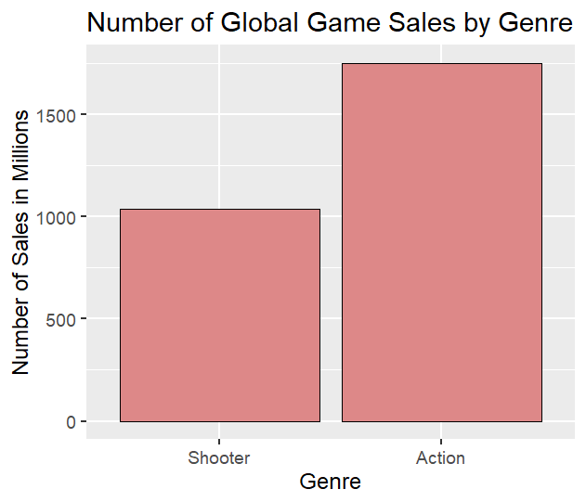.001*.* The Cohen’s D effect size is 0.19, showing the differences between action genre sales and shooter genre sales are relatively small.

Despite our findings, we see on the bar plot that action games sold nearly 1.5 times more than shooter games. We can attribute this disparity to the fact that there are 3 times more action games than shooter games. However, the mean number of shooter games sold is higher and has a smaller standard deviation than action games. Therefore, we would recommend that the next game developed should be in the shooter genre in order to have the most potential sales.

Despite our results, our study still has its’ limitations. One such is the fact that the shooter genre was underrepresented in our dataset when compared to the action genre. As mentioned earlier the action genre sold more units overall, but this is only because there are more action games overall. Had the sample sizes of the two groups been more similar, we may have seen different results in the bar plot that would have been more aligned with the findings from the independent samples t-test.